 |  |  |  |  |  |  |  |  |  | curriculum.newvisions.org/social-studies  Timothy Lent - tlent@newvisions.org  Kameelah Rasheed - krasheed@newvisions.org | 
Please Read: We encourage all teachers to modify the materials to meet the needs of their students. To create a version of this document that you can edit:  1. Make sure you are signed into a Google account when you are on the resource.  2. Go to the "File" pull down menu in the upper left hand corner and select "Make a Copy." This will give you a version of the document that you own and can modify. |  |  |  |  |  |  |  |  |  |  | 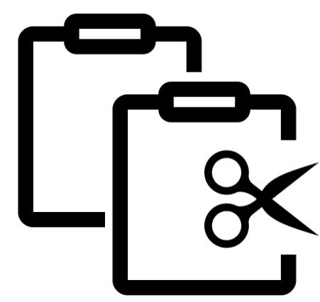
Teacher Overview: What and when was the early modern period?
Go directly to student-facing materials!

 | 9.7 Vocabulary Opener | SQ 1. What and when was the early modern period? |  | SQ 2. What was the geographic context for transformation of Western Europe and Russia in the 15th century? | 

 | Unit Essential Question(s): How did new ideas and innovation affect Western Europe and Russia starting in the 15th century? | Link to Unit
Supporting Question(s):
- What and when was the early modern period?
Objective(s):
- Describe when the early modern period occurred and what it was.

1. NYS Social Studies Framework:
Key Idea | Conceptual Understandings | Content Specifications
9.9 TRANSFORMATION OF WESTERN EUROPE AND RUSSIA: Western Europe and Russia transformed politically, economically, and culturally ca. 1400–1750. This transformation included state building, conflicts, shifts in power and authority, and new ways of understanding their world.  (Standards: 2, 3, 5; Themes: ID, MOV, TCC, GOV, CIV, TECH, EXCH) | N/A | N/A

2. Social Studies Practices
NYS Social Studies Practices | New Visions Student Social Studies Practices
Gathering, Using and Interpreting Evidence (A5, A7)  Chronological Reasoning and Causation (B1)  Comparison and Contextualization (C3, C5, C6)  Geographic Reasoning (D1, D2, D5) | Predict Categorize Identify Patterns

3. Common Core
Reading | Writing | Speaking and Listening
Craft and Structure:  CCSS.ELA-LITERACY.RH.9-10.4: Determine the meaning of words and phrases as they are used in a text, including vocabulary describing political, social, or economic aspects of history/social science.  Integration of Knowledge and Ideas:  CCSS.ELA-LITERACY.RH.9-10.7: Integrate quantitative or technical analysis (e.g., charts, research data) with qualitative analysis in print or digital text. | Text Types & Purposes:  CCSS.ELA-LITERACY.WHST.9-10.1: Write arguments focused on discipline-specific content. | Comprehension and Collaboration:  CCSS.ELA-LITERACY.SL.9-10.1: Initiate and participate effectively in a range of collaborative discussions (one-on-one, in groups, and teacher-led) with diverse partners on grades 9-10 topics, texts, and issues, building on others' ideas and expressing their own clearly and persuasively.

Associated Classroom Posters
Student Social Studies Practices Poster

Objective: | What and when was the early modern period?  - Describe when the early modern period occurred.

Introduction
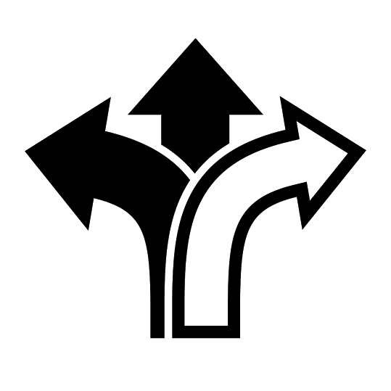  Predict | ➡ Directions: Respond to each of the questions below whose answers you know because of the Early Modern Period (1400-1800) in history.  Questions that Were Answered During the Early Modern Period (1400-1800) in History Your Response  1. Which is at the center of our solar system- the Earth or the Sun?  2. How many continents are there on Earth?  3. If you want to travel from Spain to India by boat, how could you get there?

What is periodization? How are periods determined and named?
➡ Directions: Review the definition below and answer the questions that follow.

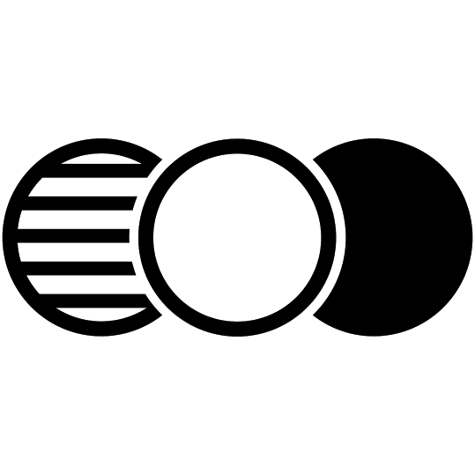  Categorize  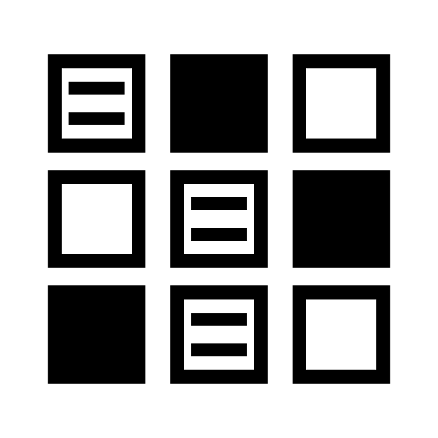  Identify Patterns | Periodization-the process or study of dividing the past into periods of time and naming them  Sometimes when historians engage in periodization, the ways they divide up the time and the labels they give to time periods has an effect on the way people think about that era and what happened during it.

1. What was the name of the time period you studied in the last three units? | 2. What characteristics did civilizations and states that you learned about in the last three units have in common?

Predict | What and when was the early modern period?  ➡ Directions: Examine the text, timeline, and images below having to do with the Early Modern Period, then respond to the accompanying prompts.

The time period you will study in Units 7, 8, and 9 is known the  “Early Modern Period/Era/Age” | 1. What do you think of when you read the word “modern?” | 2. What might early modern mean?

3. Circle the words or phrases in the definition to the right that you do not know or are confused by. | Early Modern Era/Period/Age (1400-1800)  The Early Modern Period was a time when states in Western Europe and Russia gained substantial power and wealth for the first time since the Fall of the Roman Empire started the Middle Ages. Western Europe and Russia entered golden ages that included the cultural movement called the Renaissance, a rebirth of innovation in science and math known as the Scientific Revolution, and an intellectual movement called the Enlightenment. Many of the ideas and innovations that spurred those movements came to the region through cultural diffusion from trade with the Middle East, India, and China.  This was also a period of conflict in Western Europe and Russia in which absolute monarchs waged war against one another and religious upheaval resulted from the Protestant Reformation.  The greatest impact this period had on the world resulted from the European Age of Exploration in which European states competed to gain access to raw materials and markets in Asia by sailing over trans-oceanic water-routes and inadvertently “discovered” the American continents, laying claim to the land and bringing the eastern and western hemispheres of the world together.
4. Based on the definition to the right, why do you think we study the Early Modern Period?

Timeline of Human History
Ancient
History
Classical
Era
10,000 BCE- 630 C.E.
600 BCE- 900 CE
Post-Classical Era
476- 1500 CE
Early Modern
Period
1400- 1800 CE
Late Modern
Period
1800- Present

5. Based on the timeline above, in what time period did the Neolithic Revolution and establishment of the first civilizations take place? | 6. Based on the timeline above, during which years did all of the Classical Civilizations exist? | 7. Based on the timeline above, during which era was the Byzantine Empire at its height?
8. Based on the timeline above, what time period did the Crusades take place in? | 9. Which event led to the start of the post-classical era? | 10. In 1492, Christopher Columbus and the sailors on his voyage landed in the Caribbean. Which time period did that take place in?

Each of the images below come from or represent events that happened during the Early Modern Period.
Image was created by sailko and is published on Wikimedia Commons under a CC BY license.  See List three things you see in the image above. Think Based on your observations, what do you think this is an image of? Where did it come from? Wonder Write two questions you have about the picture above. | Image is courtesy of Wikimedia Commons and is public domain. See List three things you see in the image.  Think  Based on your observations, what do you think this is an image of?  Wonder  Write two questions you have about this painting..

Image is courtesy of Wikimedia Commons and is public domain.  See List three things you see in the image above. Think Based on your observations, who do you think this is an image of? What was its purpose? Wonder Write two questions you have about the picture above. | Image is courtesy of Wikimedia Commons and is public domain.  See List three things you see in the image above. Think Based on your observations, what do you think this is a diagram of? Wonder Write two questions you have about the picture above.

Source: Steven Goldberg and Judith Clarke DuPré, In Brief Review in Global History and Geography, Prentice Hall (adapted) from the NYS Global History and Geography Regents Exam.  See List three things you see in the image above. Think Based on your observations, what do you think this map shows? Wonder Write two questions you have about the picture above. | Taken from the New York State Education Department. June 2006. Global History Exam. Internet. Available here; accessed August 7, 2017..  See List three things you see in the image above. Think Based on your observations, what do you think this map shows? Wonder Write two questions you have about the picture above.

FA | SQ 1: What and when was the early modern period?  ➡ Directions: Using evidence from the information above, respond to the task below in the space provided.
Predict | Task:  - Describe when the early modern period occurred and what it was.

